

American International University-Bangladesh (AIUB)   
**Department of Computer Science  
Faculty of Science &Technology (FST)   
Fall 23 24**

**EasyTravel**

*An Accompanying Tourist*

Software Requirement Engineering

Sec: **A**

Project submitted

By

|  |  |
| --- | --- |
| **STUDENT NAME** | **ID** |
| **Syed Mohibur Rahman** | **20-42043-1** |

**Checked By Industry Personnel**

**Name:**

**Designation:**

**Company:**

**Sign:**

**Date:** 25/12/23

1. **PROBLEM DOMAIN**
   1. **Background to the Problem**

Presenting EasyTravel the ideal travel companion for adventurers everywhere. The goal of EasyTravel is to match vacationers with unusual experiences, locations, and travel packages. For anybody who enjoys travelling and wants to get the most out of their excursions, this is the ideal platform.

After a group of enthusiastic travelers struggled to discover genuine travel experiences that didn't break the wallet, the idea for EasyTravel was born. They desired to provide something unique as they saw that the majority of trip booking websites were overrun with same, generic packages. Something that would enable visitors to experience new areas, make connections with people, and fully immerse themselves in the local way of life.

The goal of EasyTravel is to increase everyone's access to, enjoyment from, and affordability of travel. They achieve this by collaborating with regional tour operators, guides, and travel agencies to create distinctive, adaptable vacation packages that suit a variety of interests and price points.

EasyTravel offers something for everyone, regardless of your interests—a gourmet seeking to sample the delectable cuisine of Paris or an adventure seeker hoping to walk across the Himalayas. With a straightforward search feature that lets visitors narrow down results by activity, budget, destination, and more, our website is user-friendly.

EasyTravel, however, is more than simply a website for arranging trips. In order to assist travelers in organizing their excursions and making the most of their time overseas, they also provide a variety of tools and information. This consists of in-depth location guides, advice for travelling, and a community forum where users can interact with one another and discuss their travel experiences.

The dedication of EasyTravel to ethical and sustainable travel is one of its main characteristics. We think that travelling should be about more than just crossing things off of our bucket lists; it should also be about protecting the areas we go and helping the local populations. For this reason, we collaborate with neighborhood groups and projects to advance eco-friendly travel strategies and support the areas in which we operate.

* 1. **Solution to the Problem**

EasyTravel website can become an essential tool for travelers because it provides convenience, cost savings, wide selection, user-friendliness, time-saving, transparency, and reviews and recommendations. Some Importance of this is websites:

1. **Convenience**: EasyTravel websites offer a one-stop-shop for travelers to research, plan, and book their entire trip. This makes the process much more convenient for travelers who don't have the time or resources to do extensive research on their own.
2. **Cost-Effective**: EasyTravel websites often offer discounted rates on flights, hotels, and vacation packages. This can help travelers save money on their trips and make travel more accessible to a wider range of people.
3. **Wide Selection**: EasyTravel websites provide travelers with a wide selection of travel options, including different destinations, accommodations, and activities. This allows travelers to customize their trips to meet their individual preferences and interests.
4. **User-Friendly**: EasyTravel websites are user-friendly and easy to navigate. They provide travelers with detailed information about destinations, accommodations, and activities, which makes it easier to plan and book a trip.
5. **Timesaving**: EasyTravel website saves travelers time by streamlining the booking process. Instead of spending hours researching different travel options, travelers can simply search for what they want and book it quickly and easily. It has a geo-tracking service which will help travelers to find booked hotels at ease and find nearby available hotels.
6. **Transparency**: EasyTravel websites provide travelers with transparency in pricing and availability. This means that travelers can compare prices across different providers and make informed decisions about their travel plans.
7. **Reviews and Recommendations**: EasyTravel websites offer reviews and recommendations from other travelers. This can be invaluable information for travelers who want to know what to expect from a particular destination, hotel, or activity.
8. **SOLUTION DESCRIPTION**

We aim to provide an intuitive and user-friendly platform that simplifies the process of booking a trip. Here are some key features that could be included in our project:

1. **Advanced Search**: An advanced search function that allows users to search for flights, accommodations, and activities based on their preferred dates, destination, budget, and other criteria.
2. **Customized Packages**: The ability to create customized travel packages based on the user's preferences and interests. This could include pre-built packages or the option to build a package from scratch.
3. **Reviews and Ratings**: A section for user reviews and ratings of hotels, flights, and activities. This feature allows travelers to make more informed decisions and select the best options for their needs.
4. **Mobile Compatibility**: A responsive design that works well on mobile devices, so users can easily access the site from their smartphones or tablets.
5. **Secure Payment**: A secure payment system that accepts multiple payment methods and ensures that user data is protected.
6. **Customer Support**: A customer support team that is available to answer questions and resolve issues related to bookings, cancellations, and refunds.
7. **Personalization**: Personalized recommendations and suggestions based on the user's search history and preferences.
8. **Travel Guides**: Comprehensive travel guides that provide information about destinations, cultures, languages, currencies, and other useful tips for travelers.
9. **Real-Time Updates**: Real-time updates on flight status, weather conditions, and other important travel information.
10. **Social Media Integration**: Integration with social media platforms that allow users to share their travel experiences and connect with other travelers.
    1. **. System Features**

EasyTravel websites have some most essential features they are:

1. Advanced search. [High]
2. Interactive maps [Medium]
3. Secure payment gateway [High]
4. Booking management [High]
5. Travel communities [Medium]
6. Reviews and ratings [Low]
7. Personalized recommendations [Medium]
8. User accounts [High]
9. Travel guides and recommendations [Medium]
10. Real-time updates [High]
11. Local event calendar [Low]
12. Multilingual support [Medium]
13. Cursorial media integration customer support [Low]
    1. **UML Diagrams**

**Use Case Diagram**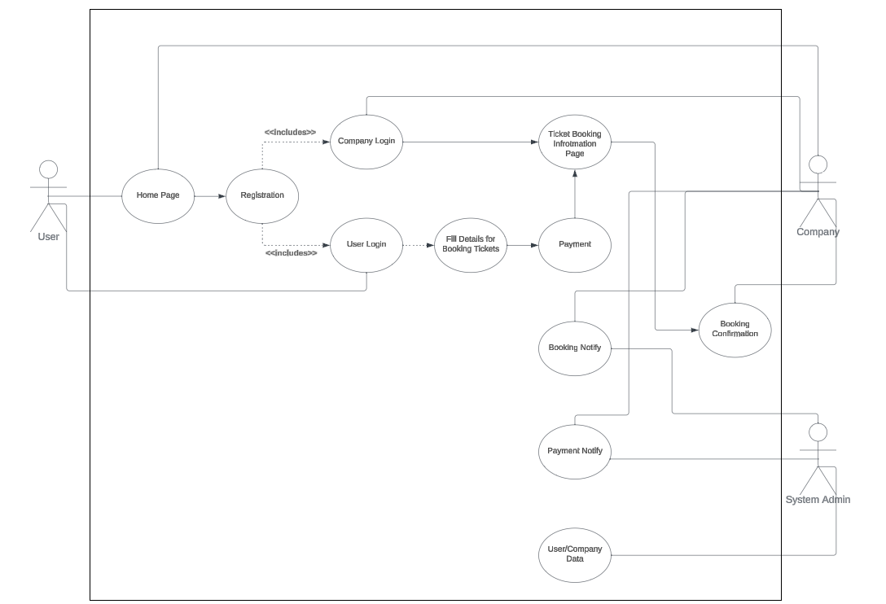

Note: Use case diagram of EasyTravel

**Activity Diagram**

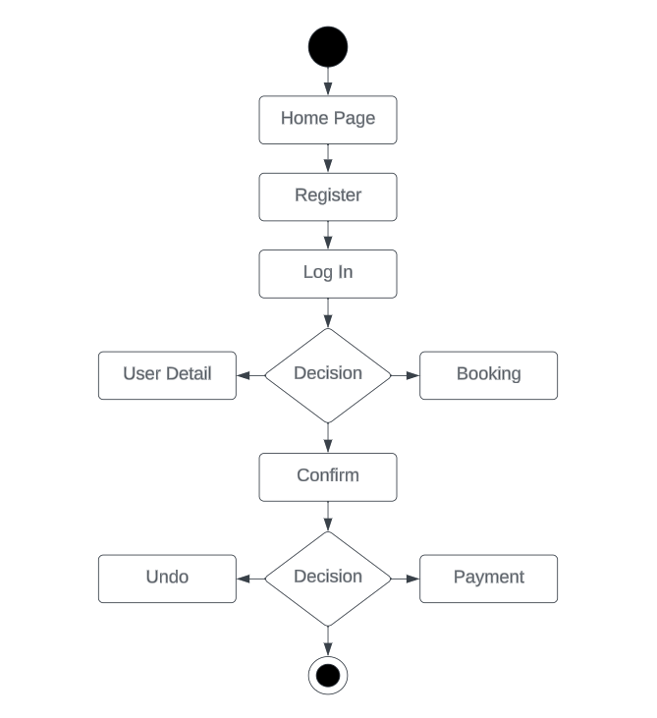

Note: Activity diagram of EasyTravel

**ER Diagram**

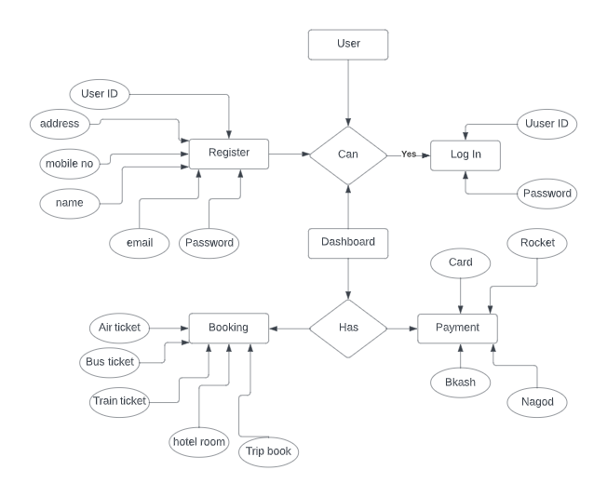

Note: Entity-Relationship diagram of EasyTravel

1. **Social Impact**

Travel booking websites have a significant social impact, both positive and negative. Here are some examples:

**Positive Social Impact:**

1. Boosting the economy
2. Cultural exchange
3. Environmental conservation
4. Job creation
5. Education

**Negative Social Impact:**

1. Overcrowding
2. Displacement of communities
3. Exploitation of workers
4. Cultural appropriation
5. Carbon footprint

In summary, EasyTravel websites can have both positive and negative social impacts. By promoting sustainable tourism practices, supporting local communities, and fostering cultural exchange, travel booking websites can contribute to positive social impact while minimizing the negative impact.

1. **Development Plan with Project Schedule**

Developing a travel booking website requires careful planning, design, and development. Here is an outline of a potential development plan with a project schedule for a new startup travel booking website:

1. Planning phase (1-2 weeks)
2. Design phase (2-4 weeks)
3. Development phase (6-8 weeks)
4. Integration phase (2-3 weeks)
5. Launch and testing phase (1-2 weeks)
6. Maintenance and support phase (ongoing)

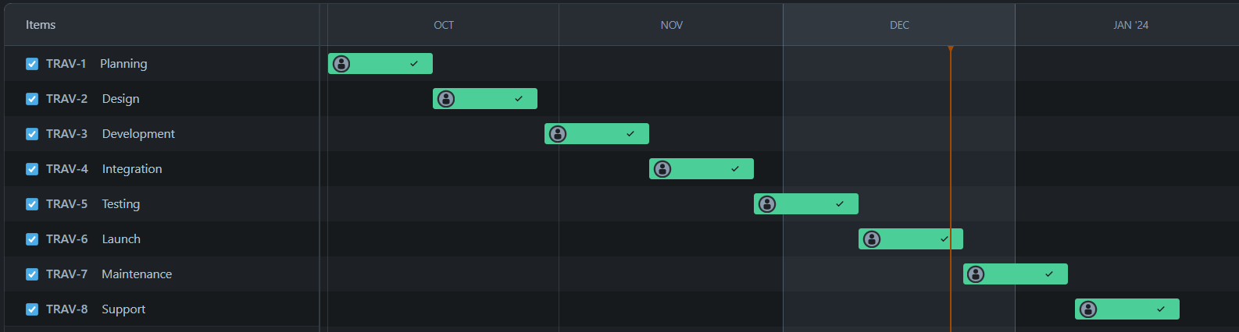

**Assign members with task schedule:**

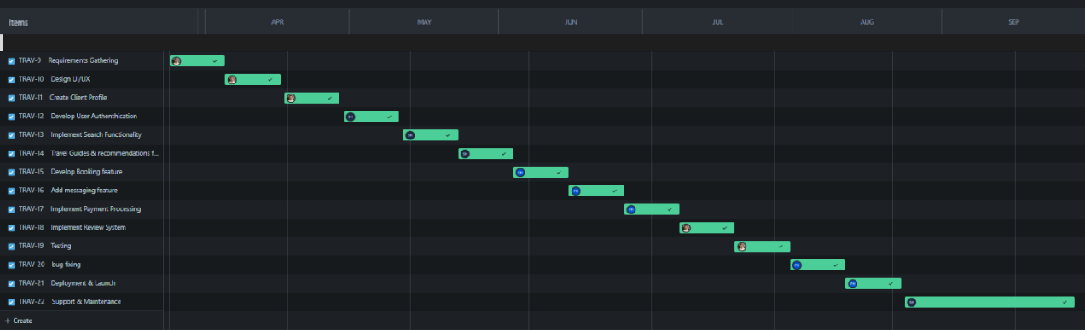

In summary, developing an EasyTravel website requires careful planning, design, development, integration, launch, testing, maintenance, and support. Following a detailed project schedule can help ensure that the website is delivered on time, within budget, and meets user requirements.

1. **Marketing Plan**

Developing an effective marketing plan is critical for the success of any new startup EasyTravel website. Here is an outline of a potential marketing plan:

1. **Market Analysis:** Studying the competition, target audience, and the overall environment to identify opportunities and challenges. This analysis helps businesses make informed decisions about their marketing strategies, product development, and pricing.
2. **Target Audience:** Defining your target audience is like painting a picture of ideal customers. It involves understanding their demographics, interests, needs, and behavior. By understanding our target audience, we will create marketing campaigns that resonate with them and increase the chances of conversion.
3. **Branding:** Branding is the essence of our business. It's what makes us unique and memorable to our customers. Our brand encompasses logo, colors, messaging, and overall personality. A strong brand builds trust and loyalty, attracting customers and setting us apart from the competition.
4. **Content Marketing:** Content marketing is about creating and sharing valuable content with our target audience. This could be blog posts, articles, infographics, videos, or anything else that educates, entertains, or inspires. By providing valuable content, we will establish our self as an expert and build relationships with potential customers.
5. **Search Engine Optimization (SEO):** SEO is the art of optimizing website and online content to rank higher in search engine results pages (SERPs). When people will search for keywords related to our business, we want our website to appear at the top of the results. This will increases organic traffic and leads to more customers.
6. **Social Media Marketing:** Social media marketing is leveraging social media platforms to connect with target audience and promote brand. It's about creating engaging content, running targeted ads, and interacting with our followers. By using social media effectively, we can build brand awareness, generate leads, and drive sales.
7. **Influencer Marketing:** Influencer marketing involves partnering with individuals who have a large following on social media or in their industry to promote our brand. These influencers can help us reach a wider audience, build trust, and drive results.
8. **Paid Advertising:** Paid advertising is a quick way to reach a large audience with our marketing message. We will pay to run ads on search engines, social media platforms, and other websites.
9. **Email Marketing:** Email marketing is a powerful tool for staying connected with customers and promoting our products or services. By segmenting our email list and sending targeted campaigns, we can personalize our message and increase engagement.
10. **Referral Marketing:** This word-of-mouth marketing can be highly effective, as people are more likely to trust recommendations from someone they know. Offer attractive referral rewards to encourage our customers to spread the word.

Developing a comprehensive marketing plan that includes market analysis, defining target audience, branding, content marketing, SEO, social media marketing, influencer marketing, paid advertising, email marketing, and referral marketing can help new startup travel booking website attract and retain customers, build brand awareness, and drive sales.

1. **Cost and Profit Analysis**

To perform a cost and profit analysis for a new startup booking website, we need to consider various factors that impact the company's revenue and expenses. Here are some important things to consider:

1. Development costs.
2. Marketing and advertising costs.
3. Staffing costs.
4. Server and hosting costs.
5. Payment processing fees.
6. Customer acquisition costs.
7. Revenue streams.
8. **Development Costs**: This includes the cost of designing, developing, and testing the EasyTravel website. Assuming a team of local developers and designers working on the project, the cost could range from BDT 500,000 to BDT 1,000,000.
9. **Marketing and Advertising Costs**: This includes the cost of promoting the website through various channels, such as social media, online ads, and other marketing strategies. Depending on the scale and scope of the marketing campaigns, the cost could range from BDT 50,000 to BDT 200,000.
10. **Staffing Costs**: This includes the salaries and benefits of employees, including developers, marketers, customer service representatives, and other staff members. In Bangladesh, the cost of hiring skilled employees is relatively low compared to other countries. Assuming a team of 5 employees, the cost could range from BDT 1,000,000 to BDT 2,000,000 per year.
11. **Server and Hosting Costs**: This includes the cost of hosting the website on servers and any additional expenses such as domain name registration. The cost of hosting and server maintenance in Bangladesh is relatively low, and could range from BDT 50,000 to BDT 100,000 per year.
12. **Payment Processing Fees**: This includes the fees charged by payment processors such as Stripe or PayPal for processing transactions. The cost of payment processing fees varies depending on the payment gateway and the volume of transactions processed. Assuming a fee of 2%, the cost could range from BDT 20,000 to BDT 50,000 per year.
13. **Customer Acquisition Costs**: This includes the cost of acquiring new customers through promotions, referral bonuses, or other incentives. Depending on the scale and scope of the customer acquisition campaigns, the cost could range from BDT 50,000 to BDT 100,000.
14. **Revenue Streams**: This includes the revenue that the startup generates from booking fees, subscription fees, or other monetization models. Assuming a booking fee of 5% and 10,000 bookings in the first year, with an average booking value of BDT 5,000, the revenue would be BDT 2,500,000.

Based on these estimates, the total expenses for the first year could range from BDT 1,670,000 to BDT 3,450,000. Therefore, the profit would be BDT 2,500,000 (revenue) - BDT 1,670,000 to BDT 3,450,000 (expenses) = BDT 830,000 to BDT 780,000.

It's crucial to remember that these are only estimates, and that the real expenses and income may change depending on a number of variables including the state of the market and the level of competition. Nonetheless, a low-budget startup booking website may still turn a profit if it can find inexpensive ways to attract users and create income through effective monetization strategies.

1. **Reference**
2. <https://www.booking.com/content/about.html>
3. <https://codetheorem.co/blogs/must-have-features-for-travel-website>
4. <https://www.businessnewsdaily.com/10600-business-ideas-travel-lovers.html>
5. <https://www.turing.com/resources/30-software-business-ideas-for-start-ups>.
6. https://www.namecheap.com/?fbclid=IwAR1zSkt4e0Sxjz7bXiFMHpf0HKtn3bK-wyPRZ08IyukXDn2n9ryZVtKGh2E